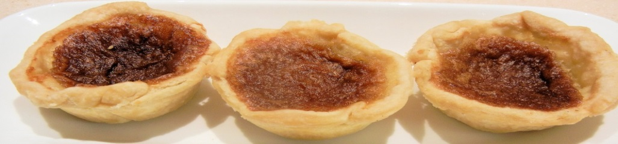
2020 Butter Tart Festival Non-Food Vendor Application
November 7, 2020
Business Name:_______________________________________________________________
Contact Name:________________________________________________________________
Address:_______________________________ Postal Code:___________________________
City/Town:_______________________________
Phone Number:______________________ Alternate Phone:__________________________
Email:___________________________________
Vendor Description:____________________________________________________________
APPLICATION MUST BE CONFIRMED PRIOR TO SENDING YOUR PAYMENT. This is to allow only 1 of the same type of vendor. Application should be emailed to events@uovchamber.com
VENDOR FEE:
______ $40 for a 6’ table - INCLUDES TABLE AND 2 CHAIRS
______ I need electrical access (you must supply your own extension cord).
Payment for Vendor Fee should be submitted via e-tranfer to manager@uovchamber.com once your application is approved.
Date:______________________ Signature:_____________________________
IMPORTANT INFORMATION
Only 1 (one) of the same type vendor will be allowed, based on 1st come, 1st served
LOCATION: All non-food vendors will be set up in Library Hall of the Petawawa Civic Centre (upstairs is available to only those selling Butter Tarts & Other Baked Goods). There will be signs directing people to both areas of the Festival.
SET UP TIMES: Saturday, November 7th, 2020 from 8:00 am to 10:00 am. You should be ready 15 minutes prior to doors opening.
FESTIVAL TIME: The Butter Tart Festival runs 10 am to 4:00 pm.

