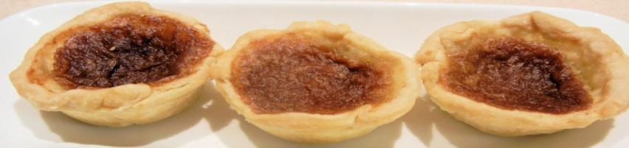
2020 Butter Tart Festival Vendor -
Butter Tarts & Baked Goods Application (Professionals Only)
November 7th, 2020
Business Name:_______________________________________________________________
Contact Name:________________________________________________________________
Address:_______________________________ Postal Code:___________________________
City/Town:_______________________________
Phone Number:______________________ Alternate Phone:__________________________
Email:___________________________________
Vendor Description:____________________________________________________________
APPLICATION IS COMPLETE ONCE PAYMENT AND CERTIFICATE OF INSURANCE HAS BEEN RECEIVED AND CONFIRMED.
_____ I have attached my certificate of commercial liability insurance for my business. (required)
_____ I require electrical access (you must supply your own extension cords)
VENDOR FEE: $125 for 2 – 6’ tables INCLUDES TABLE AND 2 CHAIRS
Payment for Vendor Fee should be submitted via e-transfer to manager@uovchamber.com at the time of registration.
BY SIGNING, I UNDERSTAND THAT MY CONTACT INFORMATION WILL BE SENT TO THE RENFREW COUNTY HEALTH UNIT.
Date:______________________ Signature:_____________________________
IMPORTANT INFORMATION:
There is a maximum of 25 (twenty-five) Butter Tart & Other Baked Goods vendors allowed Based on 1st come, 1st served basis. It is recommended that you submit your application, proof of insurance and payment ASAP to reserve your space.
SET UP TIME: Saturday, November 7th, 2020 from 8:00 am to 10:00 am. You should be ready 15 minutes prior to doors opening.
FESTIVAL TIME: The Butter Tart Festival runs 10 am to 4:00 pm.
If you wish to enter the Butter Tart Contest you must fill out the separate Professional Division Contest Application.

