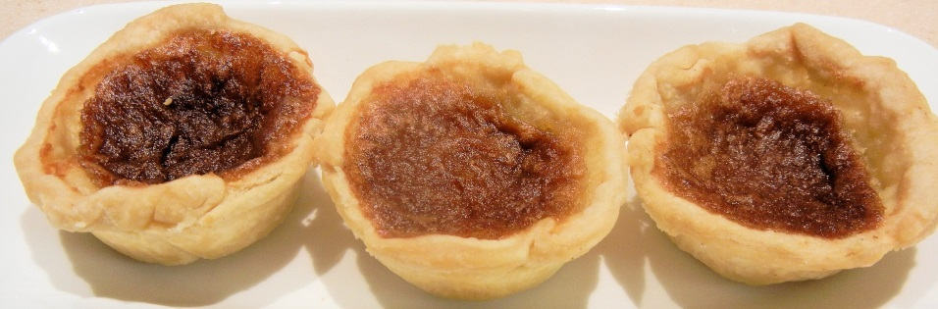

Wow, what a day! The 1st Ottawa Valley Butter Tart Festival and Contest was a huge success!
Here is what you have been waiting the winners!!
Professional Division: Traditional Category
1st Place Blue Ribbon - The Cottage Cup, Golden Lake (Plain)
2nd Place Red Ribbon - Eganville's Finest Ice Cream, Eganville (Plain)
3rd Place White Ribbon - Eganville’s Finest Ice Cream, Eganville (Pecan)
Home/Amateur Division: Traditional Category
1st Place Blue Ribbon - Cathy Malette, Foresters Falls (Plain)
2nd Place Red Ribbon - Allan Boudreau, Cobden (Plain)
3rd Place White Ribbon - Tanya Labelle, Franktown (Raisin)
Professional Division: Valley Style
1st Place Blue Ribbon - Eganville’s Finest Ice Cream, Eganville (Maple Bacon)
2nd Place Red Ribbon - Cupcake Goodness, Oshawa (Salted Caramel)
3rd Place White Ribbon - The Cottage Cup, Golden Lake (Chocolate Chip)
Home/Amateur: Valley Style
1st Place Blue Ribbon - Kristy Barton, Pembroke (Banana’s Foster)
2nd Place Red Ribbon - Christine Lefebvre, Ottawa (Maple Bacon)
3rd Place White Ribbon - Cathy Malette, Foresters Falls (Sea Salt Caramel)
Professional Division: Specialty Category
1st Place Blue Ribbon - Eganville’s Finest, Eganville (Diabetic)
Home/Amateur Division: Specialty Category
1st Place Blue Ribbon - Margaret MacDonald, Burnstown (Gluten Free Raisin)
2nd Place Red Ribbon - Margaret MacDonald, Burnstown (Gluten Free/Dairy Free)
Thank you to all the competitors, we hope you will be back next year! The judges had 36 entries to sample, that’s a lot of butter tarts.
Thank you to our judges:
Mayor Bob Sweet, Town of Petawawa
Jayne Brophy, Pembroke Mall
William Grandy, The Shed, Petawawa
Greg Biesenthal, Riverview Heights Retirement Resident
Jamie Law, Law & Orders & Board Chair of the Carleton Place & District Chamber of Commerce

